# ARTICLE I: NAME AND ADDRESS OF THE ORGANISATION

**1.1**The organization shall be called Action For Good Health -Uganda (ACT4G HEALTH-UG)

**1.2** The organization shall be registered in accordance with the laws and guidelines of the Republic of Uganda, NGO Act (Cap 2007) and other relevant statutory regulations or legal instrument.

**1.3** The organization shall be affiliated to Non-Governmental organization, national and international networks with similar objectives and shall collaborate with the Government in execution of the project mandate and that of the Government.

**1.4** The organization shall be an independent, non-profit making body, non-partisan and shall keep within its mandate in accordance with the provision of this constitution and other rules and regulations made herein under.

**1.5** The abbreviation ‘ACT4G HEALTH -UG” shall be the accepted abbreviation of the Organization’s name and shall be accepted as a name.

# ARTICLE II: LOCATION OF THE ORGANISATION’S OFFICE

**2.1** The Headquarters of the organization shall be based at Oporot ward, Patongo town council, Agago district, Northern Uganda. The organization shall at any moment as demand may arise will extend its services to whole country or outside country.

# ARTICLE III: THE VISION OF THE ORGANISATION

**3.1** To be distinguished as a world leader among Non-governmental organization in strengthening health care system by providing capacity building, safe patient care, emergency rescue, quality research and innovations.

# ARTICLE IV: THE MISSION OF THE ORGANISATION

**4.1 Capacity Building**:

To provide outstanding mentorship in accordance to national guideline and promote learner-centered medical education

**4.2 Clinical Care**:

To deliver excellent patient and family focused care

**4.3 Research and innovation:**

To bring out advance knowledge through innovation and discovery

**4.4 Community Service and emergency rescue:**

To improve the health of the medically underserved community

To provide emergency rescue health service to affected community.

To promote health equity, gender equality and human rights

To maximizes the engagement and leadership of affected Communities to leave no one behind

# ARTICLE V: OBJECTIVES OF ACT4G HEALTH-UG

**5.1 To** develop partnerships with Government of Uganda and its medical facilities, organizations working in the similar project implemented by ACT4G HEALTH- UG to enhance our services.

**5.2** To provide health information that will empower the community to make informed choices in relation to their health.

**5.3** To set trends in medical research and offer patient care of high order.

**5.4** Tomaintain the financial and ethical integrity of the organization through sound governance, record keeping and management practices.

5.5 To strengthen government health system in order to fight pandemic like TB/LEOPOSY, HIV/AID, and MALARIA ETC

# ARTICLE VI: MEMBERSHIP

6.1 ACT4G HEALTH-UG shall not be a membership organization but will closely work with established civil society organizations, the local government and other development actors both nationally and internationally that share common interests and mandates.

# ARTICLE VIII: MANAGEMENT AND STRUCTURE

**7.0** ACT4G HEALTH-UG shall have the following membership

**7.1** The Board of directors

**7.2** Management team

**7.3** Professional Staff

**7.4** Support staff

## 7.1.1 Function and the powers of the Board

The Board shall be the supreme body of the organization, it shall be responsible for:

1. Reviewing and passing policies in the organization
2. Review performance of senior staff and/or any recruitment of senior staff that may be needed. The Board shall also advise on staffing and may on the advice of the management or on their own behalf terminate the contract of any staff in accordance with the personnel policy.
3. Mobilize resources on behalf of the Institution.
4. Provide technical and other managerial support to ACT4G HEALTH-UG management.

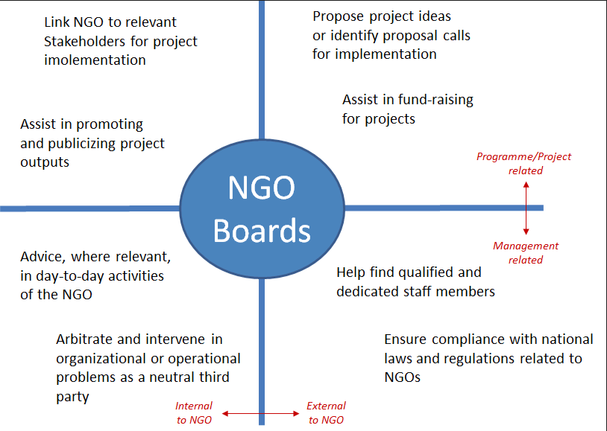

## 7.2.1 Powers and roles of the Management

The management shall comprise of Heads of Department/ Programmed and shall take on the role of directing, managing, decision making, and policy implementation monitoring and reporting all the affairs of the organization to managing director.

The management shall report directly to the managing director who shall give constant feedback to the head of department then to entire staff during monthly and reflection meetings.

## 7.3.1 Duties and responsibilities of the Staff (professional and support)

The professional staff will be the core implementation body of ACT4G HEALTH-UG and they shall be responsible for the day-day implementation of the activities of the Organization and will be closely monitored by the management team. They shall by all means represent and promote the interest of the Organization in the field and at other levels and they shall be obliged to report to the management on the progress of their work. The professional staff will be registered with all relevant governing bodies related to their occupation.

The support staff shall assist the professional staff in the execution of the activities of the organization and will be supervised by the management and receive regular training to enable them carry out their role safely and effectively.

# ARTICLE VIII: MEETINGS

## 8.1.1 Bi annual Board meetings

Bi annual board meetings shall be held to review organizational documents including narrative and financial reports, audit reports, organizational policies etc. The Board shall also be updated on the progress/performance of the organization including recruitment, funding, achievements, challenges, etc.

## 8.1.2 Management Meetings

Bi weekly management meetings shall be conducted purposely to review progress of the organization, draft and review policies, review staff performance, formulate and pass decisions in line with entire execution of the organization mandate

## 8.1.3 Monthly Review and Staff Meetings

Staff progressive review meetings shall be held weekly and head of department meeting at the end of every month to obtain relevant information regarding day to day implementation of organization activities, generate models, recommendations for bettering the organization. These monthly meetings shall also be used as feedback meetings of staff welfare.

## 8.1.4 Annual reflection meeting

Every end of the year, ACT4G HEALTH-UG shall conduct a reflection meeting that will bring together partners, staff, management and the Board to review the progress of the organization, policy issues, staffing, financing, joint planning and other issues that may require a collective decision.

# ARTICLE IX: FINANCES

9.1 The finances of the organization shall consist of:

1. Individual donations/financial contribution from members
2. Donation and grants
3. Money realized from fundraising
4. Income from consultancies
5. Any other source of income

## 9.2 Financial Year

The financial year of the organization shall follow the calendar year i.e. shall run from 1st January to 31st December of each year.

## 9.3 Banking

1. The organization shall have and operate bank accounts in lawfully licensed institutions at banks as determined by the Board Members.
2. The ACT4G HEALTH-UG management through the finance department shall manage the funds of the organization with constant approval and recommendations of the Board. The president of the organization [principle signatory], the managing director and the director Finance shall be signatories of the accounts.
3. For purposes of bank transactions, a cheque will be cleared when it holds at least two signatories with the president of the organization being the principle signatory.

# 9.4 BOOKS AND RECORDS

**9.4.1** The Organization shall keep its books and records in a proper manner and shall periodically update its books and records.

**9.4.2** The following books of accounts shall be kept:-

1. The Registration Certificate
2. The Minutes Books
3. Books of Accounts

# 9.5 AUDIT

The management team shall recommend a firm/auditor to assess the financial operations and ensure that ACT4G HEALTH-UG run efficiently. The Board shall then approve any reputable firm to audit accounts of ACT4G-UG at the end of every financial year.

# ARTICLE X: THE SEAL

**10.1** The Organization shall have an official seal that shall bear its logo and shall be kept by the Secretary.

**10.2**The Organization’s legal and other official documents shall bear the organization seal for authenticity.

**10.3** Any of the following officials of the Organization shall have authority to witness and/or authenticate the official seal.

1. The Director
2. The Deputy/Head of Programs

# ARTICLE XI: AMMENDMENT OF THE CONSTITUTION

**11.1** The Constitution or any part thereof, may be amended by the Board upon passing a special resolution to that effect supported by 2/3 of the members present. The draft copy of the proposed articles to be amended shall be prepared by the management prior to the Board meeting.

# ARTICLE XII: DISSOLUTION

**12.1** The Organization may be dissolved by a special motion moved in the Board meeting; tabled, seconded in writing by not less than ¾ of all the members of the Board present.

**12.2** A notice of intention to dissolve the organization shall be served to the Board that shall later notify all the relevant partners/parties three months before the meeting at which it is proposed to move the motion.

**12.3** The property of the organization at dissolution shall be passed on to any charity organization or partners with similar aspirations to those of ACT4G HEALTH-UG.